Rising Math 7 Honors Summer Assignment

**Mark Twain Middle School**

**Summer 2018**

**Name:__________________**

All rising **Math 7 Honors students** must complete this packet over the summer. There will be **help sessions** offered to students who need assistance completing this assignment. Please check the Mark Twain Middle School website for information regarding the dates and times for this summer’s sessions.

This assignment is due for

**ALL** Mark Twain Middle School

Math 7 Honors students on the first day of school:

**August 28th, 2017**

**Students will be assessed during the first week of school on the topics in this packet**

This assignment is due for

**ALL** Mark Twain Middle School

Math 8 students on the first day of school:

**September 6, 2016**\*\*Students will be assessed during the first week of school on the topics in this packet**

This assignment is due for

**ALL** Mark Twain Middle School

Math 8 students on the first day of school:

**September 6, 2016**\*\*Students will be assessed during the first week of school on the topics in this packet**

This assignment is due for

**ALL** Mark Twain Middle School

Math 8 students on the first day of school:

**September 6, 2016**\*\*Students will be assessed during the first week of school on the topics in this packet**

This assignment is due for

**ALL** Mark Twain Middle School

Math 8 students on the first day of school:

**September 6, 2016**\*\*Students will be assessed during the first week of school on the topics in this packet**

This assignment is due for

**ALL** Mark Twain Middle School

Algebra or Algebra Honors students on the first day of school:

**September 6, 2016**\*\*Students will be assessed during the first week of school on the topics in this packet**

This assignment is due for

**ALL** Mark Twain Middle School

Math 8 students on the first day of school:

**September 6, 2016**\*\*Students will be assessed during the first week of school on the topics in this packet**

**Topic 1: Integer Operations  
*This topic should be completed WITHOUT a calculator.**



**Integer Addition Practice:**

1. (-2) + (-9) = ________
2. -5 +13 = _________
3. 8 + -2 = _________
4. -12 + 7 = _________
5. (-4) + (-3) =_________

**Integer Subtraction Practice:**

1. 5 – 9 = ________
2. -2 – 8 = _________
3. (-15) – (-3) = _______
4. -12 - 5 = _________

10) 4 - 6 = ________

**Integer Multiplication and Division Practice:**

11) -7(6) = _________ 12) -3 • - 4 = __________ 13) 5 x ( – 8) = ________

14) -35 ÷ 7 = _________ 15) -32 ÷ - 4 = _________ 16) $\frac{-18}{6}$ = ___________

**Ordering Integers and Decimals Practice:**

17. Order from ***least to greatest***:

-5, 2, 10, -3, -1, 7 ________________________________

2.5, -3, 2, -3.5, 1 -2.5 ________________________________

18. Order from ***greatest to least***:

8, 4, -6, 11, -5, 2 _________________________________

-17, 20, -4.8, 0, -4.1, -1 __________________________________

**Topic 2: Converting and Ordering Fractions, Decimals, Percents, and Scientific Notation**

**\*This assignment should be completed WITHOUT a calculator.**

**SHOW ALL WORK!**



**Complete each conversion. Show all work. You may NOT use a calculator.** 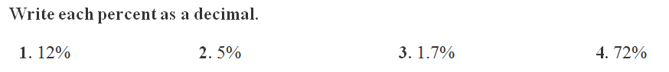

_____ ______ ______ _____

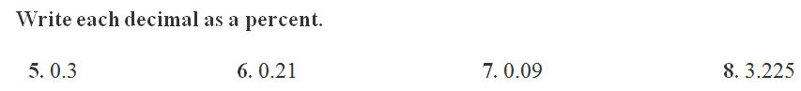

_____ _____ _____ _____

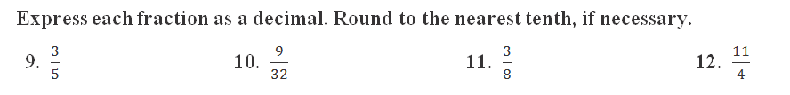

______ ______ ______ _____



**Express each number in standard form:**

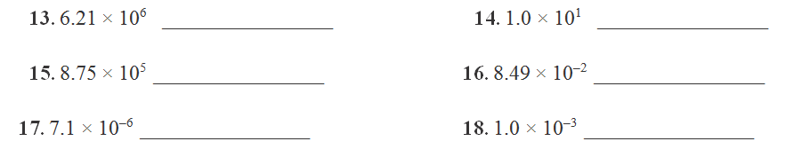

**Order the following from *least to greatest*: (Hint: Convert them to decimals, and then line up decimal points to order them)**

19.  ____________________­­­­­­­­________________



20. _______________________________________

**Topic 3: Graphing Ordered Pairs**

Plot the following points on the coordinate plane and label with the appropriate letter. Make sure your points are bold.

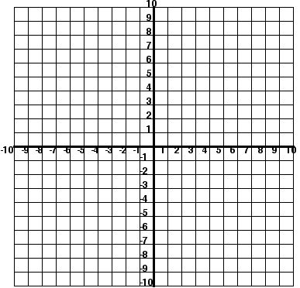

1. (5, 6)
2. (-6, 1)
3. (-4, -2)
4. (8, -3)
5. (0, 0)
6. (0, -2)
7. (7, 0)
8. (0, 5)
9. (-2, 0)
10. (3, 3)
11. (-3, 3)
12. (1, 9)

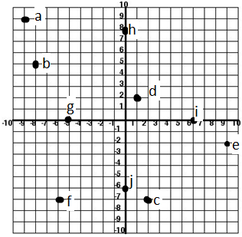Write the ordered pairs for the following points:

1. ______________
2. ______________
3. ______________
4. ______________
5. ______________
6. ______________
7. ______________
8. ______________
9. ______________
10. ______________

**Topic 4: One and Two- Step Equations**

It is expected and *essential* that you understand how to solve 1 and 2-step equations algebraically when you enter Math 7 Honors. In Math 7 HN, we focus on multi-step equations and equations with variables on both sides.

**Examples:**

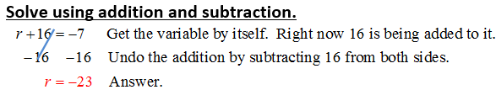

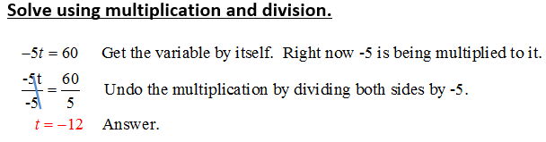

**Solve for x, showing each step like above.**

1)  2) 

3)  4) 

5) 7 + w = -10 6) -3c = -24

1.  8) 3.5 = g – 6

**2-Step Equations**

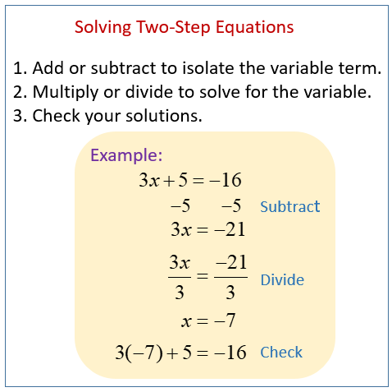

**Your Turn: Solve each equation, showing each step. Check your solution.**

1) 80 = 10*d* – 20 2) 59 = 7*x* + 10

3) 5*p* - 8 = 22 4) 15 + 2*x* = 75

5) = 18 6) +

7)  8) -6 – 3*x* = 12

**Topic 5: One-Step Inequalities**

It is expected and *essential* that you understand how to solve and graph a one-step inequality.

**Graph the inequalities:**

1. 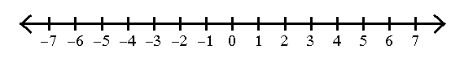x < -4 2) y ≥ 3



3) w -1 4)  -4 > x



**Solve each inequality and graph the solution. Show all work.**

5) 6)

 

7) 8)

 

9) 10)

 