

**Mark Twain Middle School Summer 2018**

**Name:**

All rising **Math 7 students** must complete this packet over the summer. There will be **help sessions** offered to students who need assistance completing this assignment. Please check the Mark Twain Middle School website for information regarding the dates and times for this summer’s sessions.

This assignment is due for

**ALL** Mark Twain Middle School

Math 7 students on the first day of school:

**August 28th, 2018**

**Students will be assessed during the first week of school on the topics in this packet**

Operations with Fractions

Solve. Show all work and circle your answer.

1) $3\frac{3}{4}+2\frac{5}{8}=$

2) $7\frac{1}{3}-2\frac{3}{4}=$

3) $24\frac{1}{3}-19\frac{2}{3}=$

Adding and Subtracting

* Find a common denominator
* Add or subtract the numerators, but leave the denominator the same

Example: $3\frac{1}{3}$ = $3\frac{2}{6}$

$-1\frac{5}{6}$ = $1\frac{5}{6}$

$1\frac{3}{6}$ = $1\frac{1}{2}$

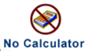

8

2

Multiplying Fractions:

* Change mixed numbers to improper fractions
* Multiply straight across. Change improper fractions back into mixed numbers.

Example: $3\frac{1}{2}×\frac{8}{10}=$

$\frac{7}{2}×\frac{8}{10} = \frac{56}{20} = \frac{14}{5} = 2\frac{4}{5}$

Dividing Fractions:

* Change mixed numbers to improper fractions.
* Find the reciprocal of the 2nd fraction (flip it)
* Multiply straight across.

Example: $2\frac{3}{4}÷\frac{5}{6}=$

$\frac{11}{4}÷\frac{5}{6} =$

$\frac{11}{4}×\frac{6}{5} = \frac{66}{20} = \frac{33}{10} = 3\frac{3}{10}$

Solve. Show all work and circle your answer.

4)

5)

6) You have $2\frac{5}{8}$ pizzas left over. If you share them equally with 9 people, how much will each person get?

How to convert a ***fraction (1/8)*** to a ***decimal (.)***

|  |  |
| --- | --- |
| 1. **Identify** the top number (***numerator***) of your fraction and the bottom number (***denominator***). | 1 Numerator  __  8 Denominator |
| 1. **Divide** the top number (**numerator**) of your fraction by the bottom number (**denominator)** | 1 ÷ 8 = _????_ |
| 1. **Solve.** | 1 ÷ 8 = 0.125 |
| When 1/8 is converted to a decimal the answer is **0.125.** | |

How to convert a ***decimal (.)*** to a ***percent %.***

|  |  |
| --- | --- |
| 1. **Complete** the previous steps. Once you have a decimal you multiply your answer by 100. | * 1 ÷ 8 = 0.125 * 0.125 x 100=___ |
| 1. **Solve.** | 0.125 x 100= 12.5 |
| 1. **Add** a % sign to your answer. | 12.5= 12.5**%** |

***PRACTICE***

|  |  |  |
| --- | --- | --- |
| **FRACTION** | **DECIMAL** | **PERCENT** |
| 1/8 | 0.125 | 12.5% |
| 1/4 |  |  |
| 3/5 |  |  |
| 4/9 |  |  |
| 9/10 |  |  |

**[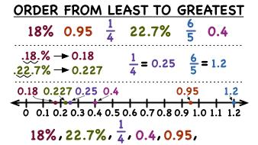](http://www.google.com/url?sa=i&rct=j&q=how+to+order+decimals,+fractions+and+percents&source=images&cd=&cad=rja&uact=8&docid=gUhejor6MVplZM&tbnid=QQDLuxIxJpK_GM:&ved=0CAUQjRw&url=http://www.prometheanplanet.com/en/Resources/Item/139216/how-do-you-put-fractions-decimals-and-percents-in-order&ei=_bmMU8HZLKTMsQSl-YHgDQ&bvm=bv.67720277,d.b2k&psig=AFQjCNFUnirmeaNtNMsSlWvqiAI6iIp5RA&ust=1401817975704910)Example:**

1. **Plot**  **on the number line below:**



1. **Order the following numbers from greatest to least.**
2. **Order the following numbers from greatest to least.**

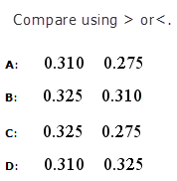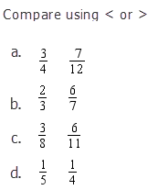

**5.**

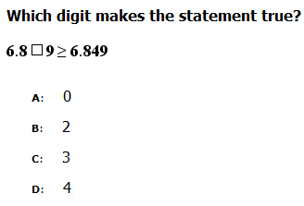

**6.**

**Absolute Value**

Absolute value is the **distance** a number is from zero.

Absolute value must always be **positive**.

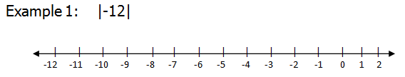

**-12 is 12 units away from 0. $\left|-12\right|=12$**

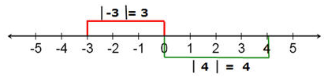**Example 2:**

Find the absolute value.

1.  2.  3.  4.  5. 

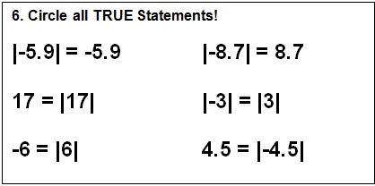

**7.**

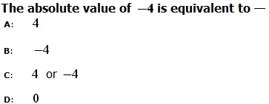

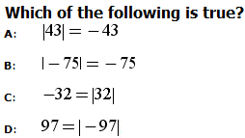**8.**

**14. Circle all TRUE Statements!**

**|-5.9| = -5.9 |-8.7| = 8.7**

**17 = |17| |-3| = |3|**

**-6 = |6| 4.5 = |-4.5|**

**14. Circle all TRUE Statements!**

**|-5.9| = -5.9 |-8.7| = 8.7**

**17 = |17| |-3| = |3|**

**-6 = |6| 4.5 = |-4.5|**

[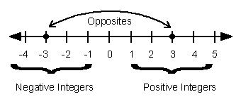](http://www.google.com/url?sa=i&rct=j&q=definition+of+integer&source=images&cd=&cad=rja&uact=8&docid=HNM5aekxUSycpM&tbnid=izdo9qgBJ6ttaM:&ved=0CAUQjRw&url=http://mrspearson.wordpress.com/2011/01/17/11/&ei=gHaIU8WLD4XLsATZx4DYBA&bvm=bv.67720277,d.b2k&psig=AFQjCNHD_5zf9L6v2KZicDbRYTcKd2QGhw&ust=1401538545457857)**Comparing, Ordering, and Representing Integers**

**Integer:** whole numbers and their opposities

**2.**

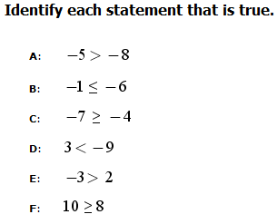

1. **Circle all of the situations   
   below that could be represented by   
   a negative integer.**

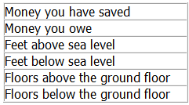

1. **Circle all of the integers below:**

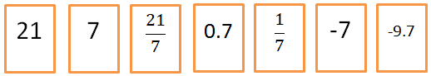

4.

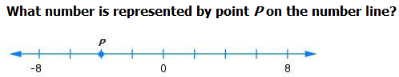

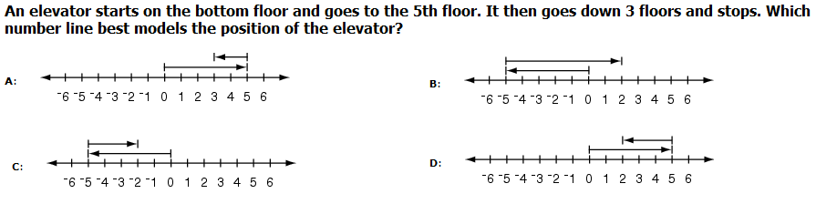5.

**Identify which number is greater by using < (less than) or > (greater than)**

1. -5 6
2. 9 -9

Order of Operations

**G** First, solve the operations inside of **grouping symbols**.

**E** Second, solve the **exponents**.

**MD** Third, solve all **multiplication** and **division** from LEFT 🡪 RIGHT.

**AS** Fourth, solve all **addition** and **subtraction** from LEFT 🡪 RIGHT.

Example:











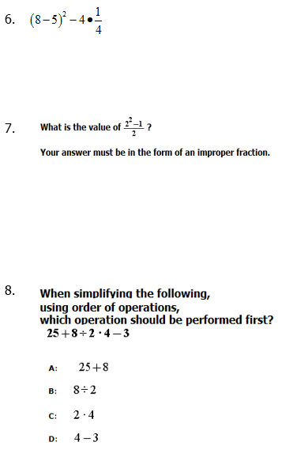**Directions: Show all work. Circle your answer.**

1. 
2. 
3. 
4. 
5. 