Rising Math 8 Summer Assignment



**Mark Twain Middle School**

**Summer 2018**

Name: ___________________________

All rising **Math 8 students** must complete this packet over the summer. There will be **two help sessions** offered to students who need assistance completing this assignment. These sessions are **open to all rising Math 8 students**. Students do not need to stay for the entire session and these sessions are not mandatory. Please check the Twain website for the dates and times of these sessions

This assignment is due for

**ALL** Mark Twain Middle School

Math 8 students on the first day of school:

**August 28th , 2018**\*\*Students will be assessed during the first week of school on the topics in this packet**

**\*\*You may use a calculator for all of this assignment\*\***

**Converting and Ordering Rational Numbers**

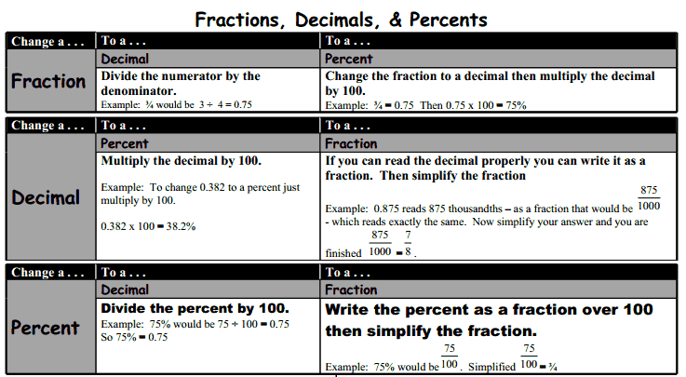

**Scientific Notation**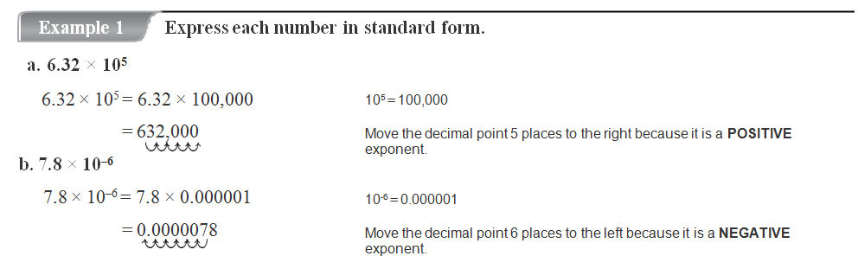

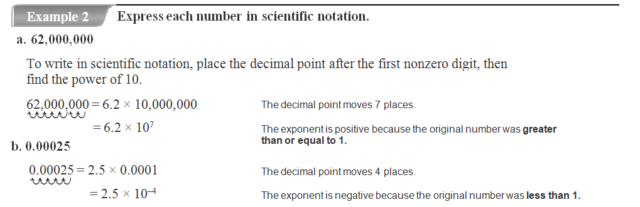

Practice

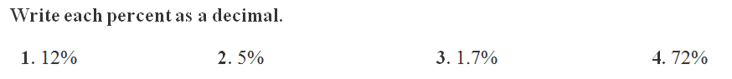

_____ ______ ______ _____

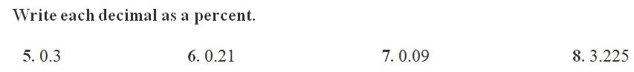

_____ _____ _____ _____

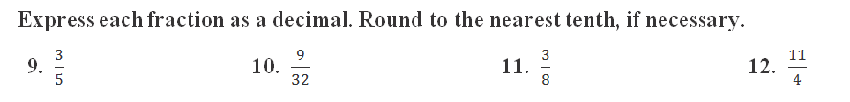

______ ______ ______ _____

**Express each number in standard form:**

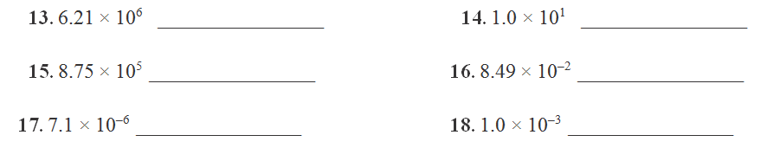

**Order the following from *least to greatest*: (Hint: Convert them to decimals, and then line up decimal points to order them)**



19. _______________________________________

  
  
20. _______________________________________

**Graphing Ordered Pairs**

**Example:** Plot the following points on the coordinate plane and label with the appropriate letter

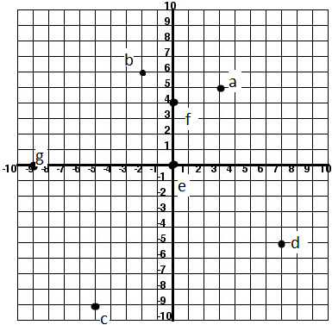

1. (3, 5)
2. (-2, 6)
3. (-5, -9)
4. (7, -5)
5. (0, 0)
6. (0, 4)
7. (-9, 0)

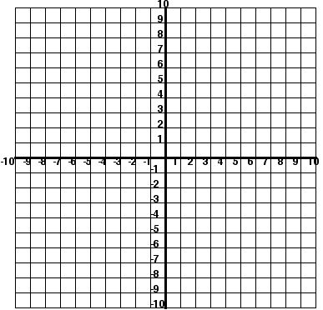**You Try!** Plot the following points on the coordinate plane and label with the appropriate letter. Make sure your points are bold.

1. (5, 6)
2. (-6, 1)
3. (-4, -2)
4. (8, -3)
5. (0, 0)
6. (0, -2)
7. (7, 0)

**Example:** Write the ordered pairs for the following points:

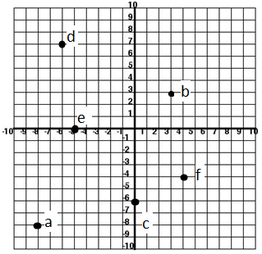

A: (-8, -8)

B: (3, 3)

C: (0, -6)

D: (-6, 7)

E: (-5, 0)

F: (4, -4)

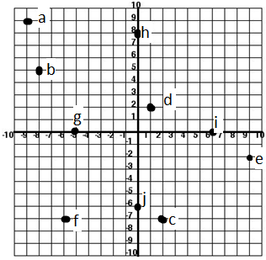**You Try:** Write the ordered pairs for the following points:

1. ______________
2. ______________
3. ______________
4. ______________
5. ______________
6. ______________
7. ______________
8. ______________
9. ______________
10. ______________

**Expressions:**

Remember: **GEMDAS**

Grouping ( ) or [ }

Exponents2

Multiplication/Division (from left to right!)

Addition/Subtraction (from left to right!)

**Simplify each expression:**

|  |  |
| --- | --- |
| $10- 3∙5$ + 2 | $$26+\left(7-2\right)∙4$$ |
| $$-3∙3+\left(-12\right)÷3$$ | $$(9-6)+4∙4+12$$ |
| $$\frac{5+(-25)}{-6+1}$$ | $$\frac{2-6∙3}{3+1∙5}$$ |

**Equations**

One Step Equations:

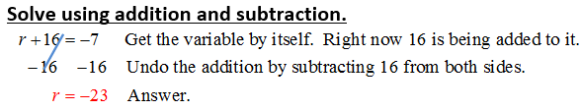

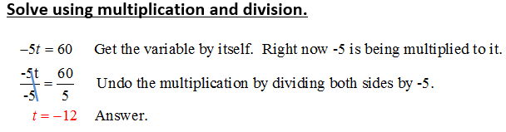

**Solve for x, showing each step like above.**

1)  2) 

3)  4) 

5) 7 + w = -10 6) -3c = -24

1.  8) 3.5 = g – 6

2-Step Equations:

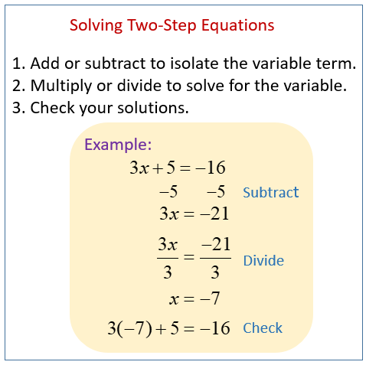

**Your Turn: Solve each equation, showing each step. Check your solution.**

1) 80 = 10*d* – 20 2) 59 = 7*x* + 10

3) 5*p* - 8 = 22 4) 15 + 2*x* = 75

5) = 18 6) +

7)  8) -6 – 3*x* = 12