Mark Twain Middle School Summer 2018

Name: _

All rising Algebra or Algebra Honors students must complete this packet over the summer. Students entering Algebra or Algebra Honors must have mastered the skills contained in this packet prior to the start of the 2018- 2019 school year. There are videos available on our Google Video Lesson site for students who need assistance completing this assignment. Please use the QR code below to access the Video Lessons. The videos will be under the Summer Packet tab.

This assignment is due for
ALL Mark Twain Middle School Algebra or Algebra Honors students on the first
day of school:
August 28, 2018
**Students will be given a graded quiz on this packet the first week of school to assess their mastery of prerequisite concepts.**

Scan the QR code to access the Summer Packet Video Lessons

Converting and Ordering Fractions, Decimals, Percents, and Scientific Notation

Examples:

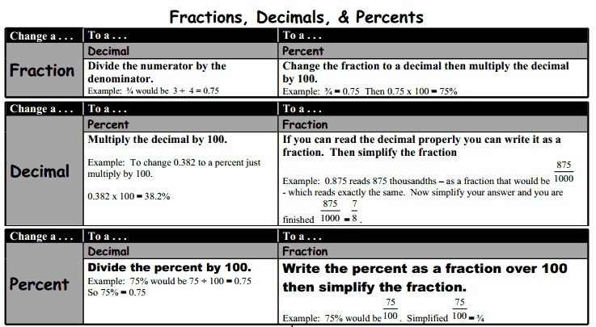
Scientific Notation

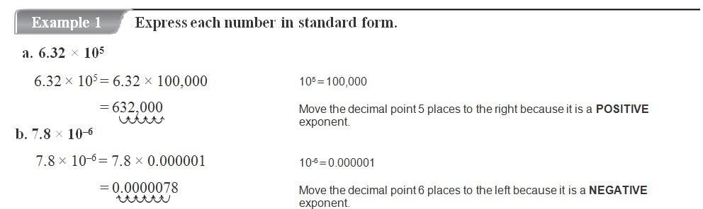

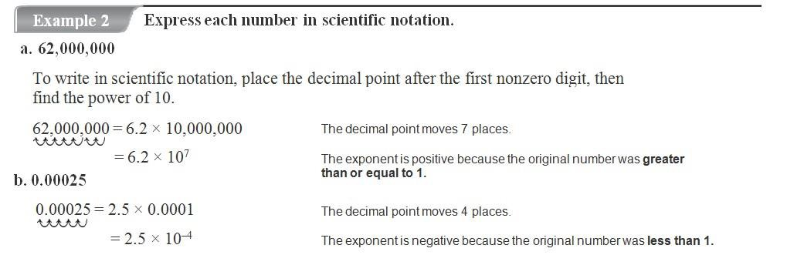

- Write in the symbol that makes the statement true, < or >.

a) 0.09 7
8
7 −3
b) 6% 0.09 c)
8.0 ×10
8

d) 8.0 × 10−3 6%

- Order the following numbers in descending order. Next, plot them on the number line below.
2/5
−3
2.5%
2.5 x 10⁻³
0.25

Answer: _________________________________________________

- Order the following numbers in ascending order and mark on a number line. 40 0.57 6/7 1.23 x 10-2 72% Answer:

- Which list is in ascending order?

3 , 30%, 3.7x10−2

B. 3 , 30%, 3.7x10−2 , 0.25

A. 0.25,
8 8

C. 3.7x10−2 , 0.25, 30%, 3
8
3
D. 30%, 3.7x10−2 ,
, 0.25
8

Translating Expressions and Equations

Translate the following to algebraic expressions:
- 8 less than the product of 5 and a number.

- The product of a number and five, subtracted from 8.

Translate the following to verbal expressions:
- The difference of one third of a given number and nine
- Twice the quantity of a number added to five.

Write an equation for the following:

- The total cost of a taxi ride is a flat $3 plus $2 per mile.

- Write a sentence that could be represented by the following equation:
6. y=4x+10

Simplifying Numerical Expressions

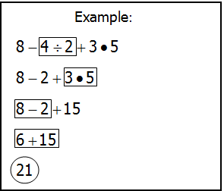
G First, solve the operations inside of
grouping symbols.
E Second, solve the exponents.
MD Third, solve all multiplication and
division from LEFT → RIGHT.
AS Fourth, solve all addition and
subtraction from LEFT → RIGHT.

Practice: Simplify the following expressions.

1.12 ÷ 3 • 5 − 42

4.
[131.625-(6.4 + 5.1)2 + 9/8]
2

2. ⎡⎣−28 •(3 − 5)+ −34 ⎤⎦ ÷(−5)2
4 ÷ 23
2
5. 1 5 +(3 )3

3. [8(3 + 4) − 28]
5 − 3

 |  | Determine square roots
1. | 49 | 2. | 100
3. | 169 | 4. | 64
5. | 196 | 6. | 400

Evaluating Algebraic Expressions

Examples:
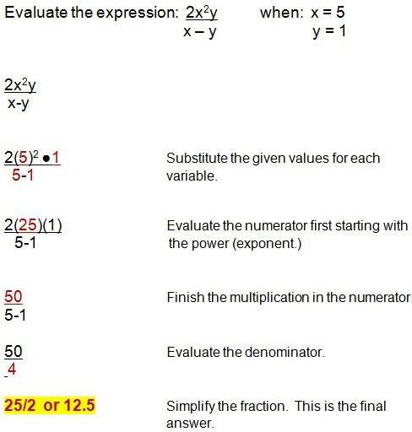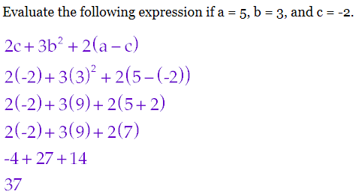

Practice:
  - Evaluate 3a + b
2

when a = 7, b = -3,
- Evaluate 7(3b – ac) when a = -2, b = 3 and c = 5.

2c
and c = -5.

Evaluate if a = 1, b = 2, c = 3
2. ½ (a + b + c)
- Evaluate c =
−a + c2 − b
.
4

when a = 3, b = -5 and

- Evaluate when a = -6, b = 2 and
2a − 3b
c

3. $\left|a-6b\right|$
The formula to convert temperature
c = 9.
4.
from degrees Celsius to Fahrenheit is 8. What is the value of 2(c + 5) + 2c2 when

given by the formula
o F = oC • 9 + 32
5
c = -1.2?

If it is 17 degrees Celsius outside, what is the temperature in Fahrenheit?

Solving Equations

Examples:

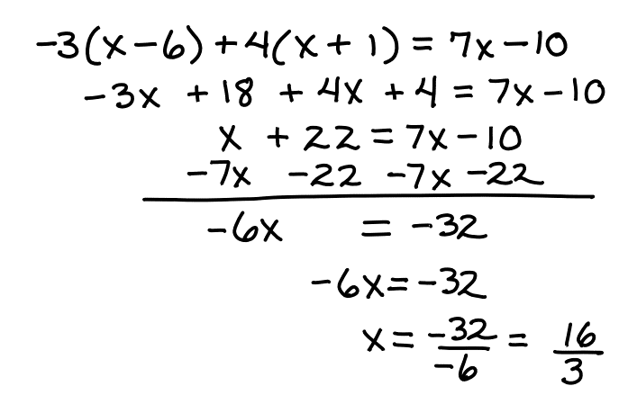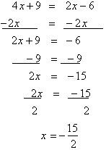

Practice: Solve the equation 6. 7x − 2x + 7 = −13
1. x  7  7

2.  3 x

5
 18

7. 9 + 4 x − 2 x = 11
3 3

3. 2x  3  23

8. 10x − 8 = 27 − 5x

4. 6x  5  43

5. −2(3y − 7) = 56 9. 6(1− 4w) = −18

Solving Inequalities Solve the inequality and graph the result on a number line. 1. −3x + 6 ≤ −3

0

2. −5 + 8x > 59

0

3. 3x + 2 > 17

0

4. −2x + 2 ≤ 20

0

Representing Relationships with Tables, Graphs, Equations and Words

Which graph best represents the line defined by the table of ordered pairs?
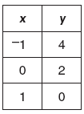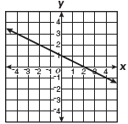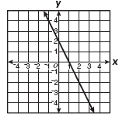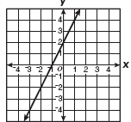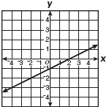
A
B
C
D

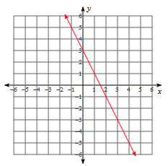
Which equation matches the graph?

  - y = 3x − 2

C. y = − 1 x + 3
2
B. y = −2x + 3

D. y = 2x + 3

Which table of values is represented by this rule?

“ Three and four- tenths times a number, x, plus two is y.
  - B. C. D.

x | y
3 | 10.2
5 | 17.0

x | y
3 | 12.2
5 | 19.0

x | y
3 | 8.2
5 | 15.0

x | y
3 | 11.12
5 | 17.2

Susie is selling cookies at a bake sale. The graph below shows how many cookies she sells after each hour has passed. Which word sentence matches the graph?

Cookies Sold

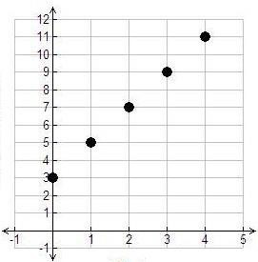

Hour

- Susie started by selling 3 cookies and sold 1 additional cookie each hour
- Susie started by selling 3 cookies and sold 2 additional cookies each hour
- Susie started by selling 2 cookies and sold 2 additional cookies each hour
- Susie started by selling 2 cookies and sold 3 additional cookies each hour

The school store sells t-shirts and sweatshirts each Friday.

- Sales totaled $565.00 last Friday
- Let t represent t-shirts, which sold for $10 each.
- Let w represent sweatshirts, which sold for $25 each.

Write an equation to represent the total sales last Friday.

- Use the table to answer questions a, b, and c.

x | -2 | 0 | 1 | 3
y | -7 | -3 | -1 | 3

- Plot the ordered pairs in the table on the coordinate plane below.

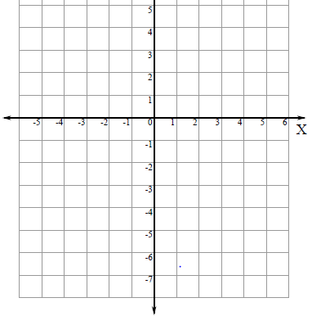

- Use words to describe the relationship found in the table.

- Write an equation for the relation that includes the ordered pairs in the table.

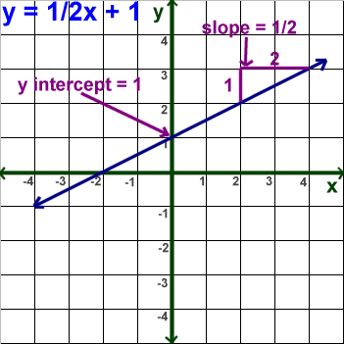
Examples:

Practice:
Graphing a Linear Equation

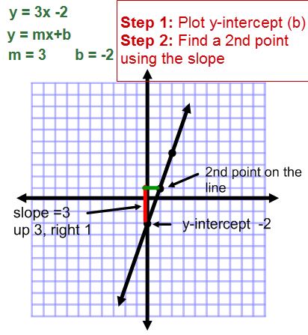
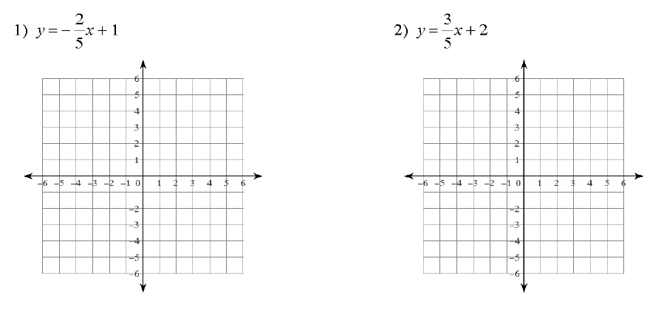

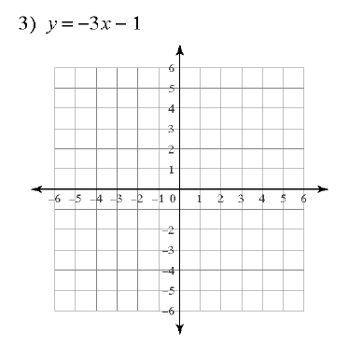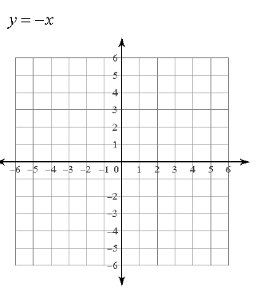
4)

